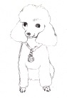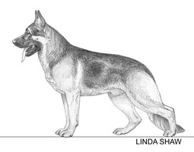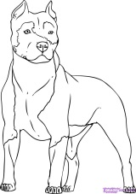http://handicappedpet.net/helppets/images/avatars/gallery/dog/White%20Backgrounds/48x48/Dogs/American_Eskimo_Dog.gif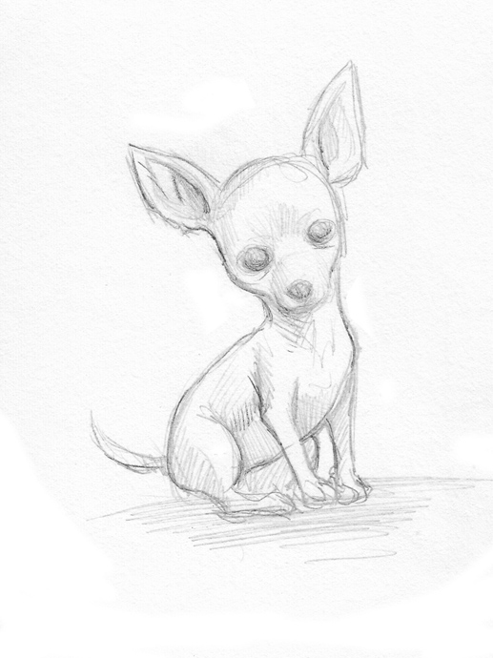

**The case of the attacked poodle**

Lori Levin’s 20 lb. poodle was brought to the emergency veterinarian, but died on arrival. Lori had been at the local dog park and was talking to a friend when her dog was attacked. Since all of the dogs were playing together at the park, multiple dog hairs were found on the poodle. Lori wants to sue the “attack” dog’s owner, but must first determine which dog is guilty. The dogs involved are: Duke the German shepherd, Izzy the Pit-bull, Katie the American Eskimo, and Charlie the Chihuahua. Use deductive reasoning to solve the case.

Facts:

Duke the German shepherd is part of the police K9 unit.

Izzy the pit-bull earned a medal for obedience class that morning and was taken to the park as a reward.

Katie the American Eskimo visited the vet this morning for vaccines.

Charlie the Chihuahua was at Kings Plaza before the dog park because her owner wanted to find the right size pocketbook to carry Charlie in, when she goes out shopping.

Duke is in training to become an arson dog. He will be able to sniff crime scenes on command.

Charlie likes to sleep on the owner’s bed, but can’t jump on and off, so the owner has to lift Charlie onto and off of the bed

Izzy the pit-bull has started training classes to be the first Pit-bull used to guide the blind on trips.

The vet suggested the owner use a new diet food for Katie since she was 30 lbs. and has lost only 5 pounds since her last visit.

Which dog attacked the Poodle? _____________________________________

List the other three dogs and describe why they can be excluded

_______________________________________________________________________________________________________________________________________________________________________________________________________________________________________________________________

Create a possible motive for attacking the poodle